Suicide Mortality in High-Income Countries

Introduction
Suicide mortality represents a significant public health challenge that every country faces, yet the suicide mortality rates vary drastically. In the United States, suicide rates have increased significantly over the last two decades. This analysis seeks to determine whether similar trends are observed in other countries and to identify national characteristics that are associated with higher or lower suicide mortality rates. By understanding these relationships, it can provide policymakers with evidence-based insights on how to improve population mental health goals and strategies.
This analysis will focus solely on high-income countries and compare key indicators to see the effect they have on the suicide mortality rate. The main goal is to study the association between suicide mortality and the selected socioeconomic and healthcare indicators, including Capital Expenditure on Healthcare, Current Expenditure on Healthcare, Life Expectancy at Birth, Out-of-Pocket Expenditures on Healthcare, and Public Spending on Education. Although education spending is not directly related to healthcare, it was included as it demonstrates broader social investments that may influence mental health outcomes
Cross-country data was collected across multiple years from the World Health Organization (WHO) and the World Data Bank to create a linear regression model to determine if there is validity to these relationships. The analysis showed a strong, statistically significant negative relationship between suicide mortality rates and life expectancy and capital expenditures, while there was a statistically significant positive relationship between suicide mortality rates and current expenditure, likely due to better reporting measures.

Literature Review
Martínez-Alés et al. (2021) examine the alarming increase in suicide mortality rate in the United States since 2000 using an epidemiological analysis in the paper “The Recent Rise of Suicide Mortality in the United States”. The research identifies when, how, and among whom suicide mortality has risen the most substantially. There was no significant acceleration after 2008 that coincides with the Great Recession. The study highlights that the increase has grown fastest among younger adults, women, and rural residents. By demonstrating that the rise reflects broad societal factors affecting all age groups, their work underscores the importance of examining national-level policies and social conditions, such as healthcare investment and economic stability, to gain a deeper understanding of this public health crisis.
Han et al. (2016) provide a critical perspective on U.S. suicide mortality by estimating the risk of death for individuals who have already attempted suicide, in the article “Estimating the rates of deaths by suicide among adults who attempt suicide in the United States”. Those who have already attempted are included in a high-risk group that is essential for targeted prevention efforts. The analysis uses nationally representative survey data linked to mortality records and calculates that the risk of suicide death within one year of an attempt is 1.8%. They also find that this risk is substantially elevated within the first 30 days, and it varies significantly by factors such as age, sex, and the presence of certain mental health disorders. This study underscores that suicide is a rare outcome of a far more common behavior, suicide attempts. Their findings suggest that policies and interventions focused on the period immediately after an attempt, such as enhanced follow-up care and means restriction, could have a substantial impact on preventing subsequent deaths.
The paper “The Gender Paradox in Suicide” by Canetto and Sakinofsky (1998) explores the “gender paradox” in suicide, which is the fact that women are far more likely to attempt suicide, while men are far more likely to die by suicide. Their analysis moves beyond biological or psychological explanations and focuses on how cultural norms, gendered roles, and social expectations shape suicidal behavior. The authors argue that in many Western societies, suicide is culturally understood as a masculine response to failure or shame, often involving violent or immediately lethal methods such as firearms. While women’s suicidal behavior is more frequently nonfatal, rooted in relational contexts, and framed as a “cry for help”. The authors conclude that this paradox is not inevitable but is socially constructed, suggesting that suicide prevention must address these gendered norms and roles to be effective across populations.

Data Description
The data for this analysis came from the World Health Organization's Global Health Observatory (GHO) and the World Bank's World Development Indicators (WDI) database. The sample includes 1,276 country-year observations, spanning from the early 2000s through 2021, and it is restricted to high-income countries to ensure comparability across the countries to the United States. While these organizations published the data, they did not directly collect all of it. Both organizations compile the national data submitted by member countries using reporting systems. The raw data that is collected is standardized, often as percentages of GDP to help with comparability across countries. Since we are only looking at high-income countries, and high-income countries generally have good reporting systems, the indicators in the data set are considered to be reliable for cross-country comparison.
The analysis will focus on five national-level indicators that help to gain an understanding of a country's healthcare system and socioeconomic environment. These variables are Capital Health Expenditure, Current Health Expenditure, Life Expectancy at Birth, Out-of-Pocket Health Spending, and Public Spending on Education. These indicators were chosen for this analysis because they help to create a well-rounded picture of population well-being and resource allocation that could relate to a country's suicide mortality rate. Capital Health Expenditure represents the long-term investments in infrastructure such as hospitals, equipment, medical technology and will help to determine whether sustained investment in health services capacity correlates with lower suicide mortality rates. Current Health Expenditure measures the recurring annual spending on healthcare delivery and it provides insight into how strongly countries fund immediately health needs. Although it is important to note this may be a reflection of higher utilization of health services and thus better mortality reporting because of it. Life Expectancy at Birth serves as a broader health indicator variable by capturing overall living conditions such as access to care, quality of life, and other social determinants that affect life expectancy and could be correlated to mental health outcomes. Out-of-Pocket Health Spending helps to measure the financial burden placed on individuals in the population when it comes to accessing healthcare. This can contribute to stress or barriers to mental health treatment and result in impacting a country's suicide mortality rate. Lastly, Public Spending on Education was incorporated as a socioeconomic measure, since countries that allocate more resources to education are typically associated with stronger support systems, higher long-term income levels, and improved health literacy, all of which may indirectly influence suicide risk.
Variable | n | Mean | SD | Min | Max
SuicideRate | 1276 | 12.63 | 8.47 | 0.00 | 53.06
CapitalExp | 322 | 0.28 | 0.26 | 0.005 | 2.49
CurrentExp | 1254 | 7.28 | 2.66 | 1.60 | 18.81
LifeExpectancy | 1276 | 78.01 | 3.83 | 64.08 | 84.56
OOPexp | 1254 | 22.87 | 10.61 | 4.86 | 57.35
PublicEduSpend | 1098 | 4.91 | 1.30 | 2.05 | 8.58
Table 1
As seen in the summary statistics, there is a large difference in data availability across the five indicators. For example, while all the countries had available information on LifeExpectancy and only 22 observations were missing from both CurrentExp and OOPexp, there were only 322 reported observations for CapitalExp. Similarly, there are gaps that appear for the reported data on PublicEduSpend, with 1,098 observations included in the analysis. These discrepancies reflect variations in how frequently individual countries' governments collect, update, and submit certain types of financial or infrastructural data. It is important to note that even with the missing information, each indicator is able to provide meaningful information and contribute to the analysis of structural and socioeconomic factors associated with suicide mortality rate across high-income countries.
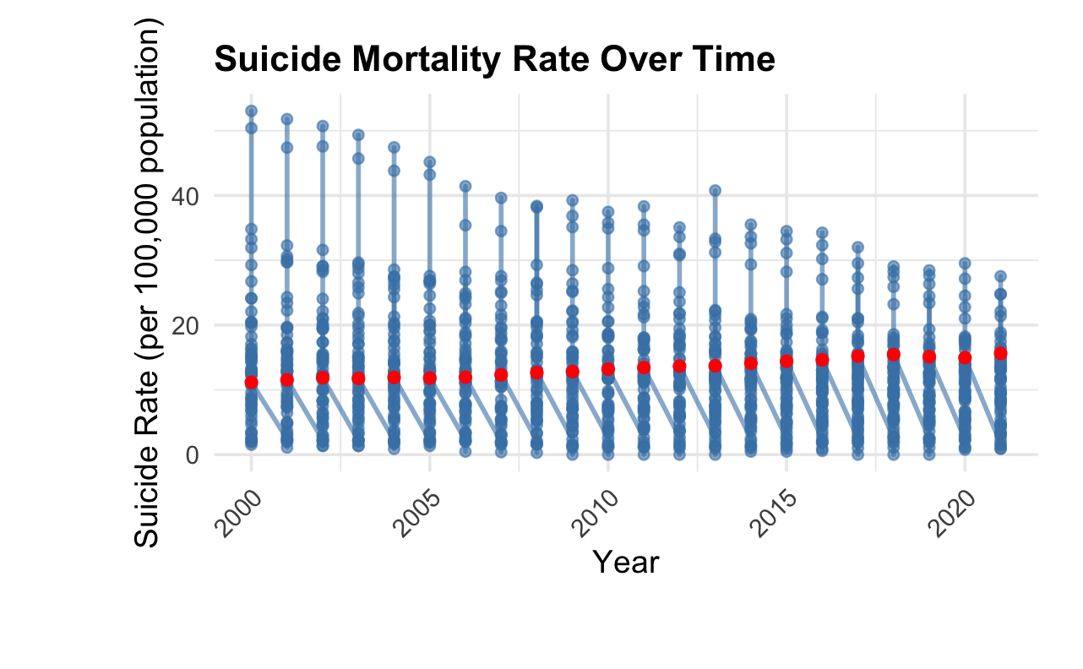
Figure 1
Figure 2
Figure 1 displays the distribution of suicide mortality rates across high-income countries from 2000 to 2021. Each year shows substantial variation across countries, with rates ranging from zero deaths per 100,000 population to above 40 in some cases. The red dots represent the United States in order to highlight its position relative to other high-income countries. Based on this graph, it is difficult to ascertain an overall trend direction for all countries; however, a gradual upward trend is observable for the United States.
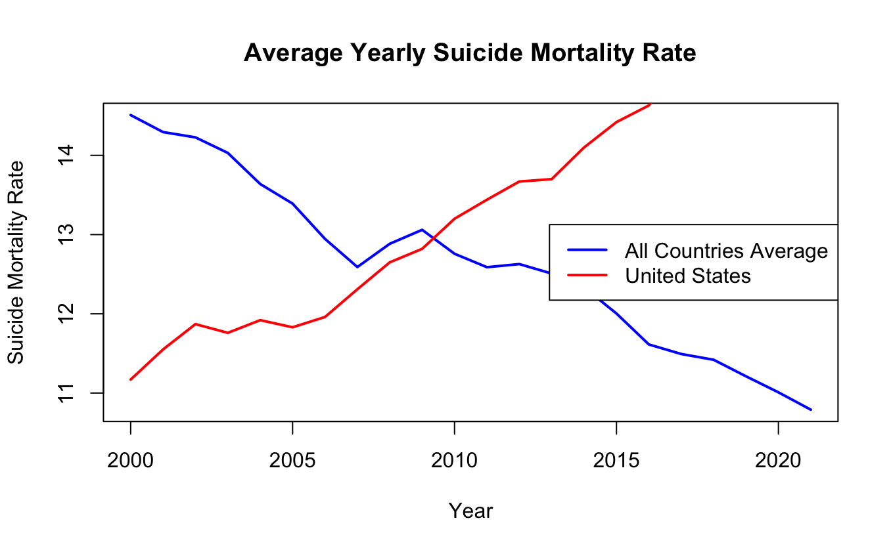
Figure 2
To better understand how the United States compares to the rest of the world, Figure 2 compares trendlines of suicide mortality rates over time, 2000 to 2021, for the average of all countries over time to the average of just the United States. While the average suicide mortality rate for all high-income countries decreases gradually over time, the United States, in contrast, demonstrates a positive upward trend. This contrast highlights a distinct and worsening public health challenge in the United States relative to peer nation, suggesting that systemic, social, or policy related factors may be driving this unfavorable trajectory.
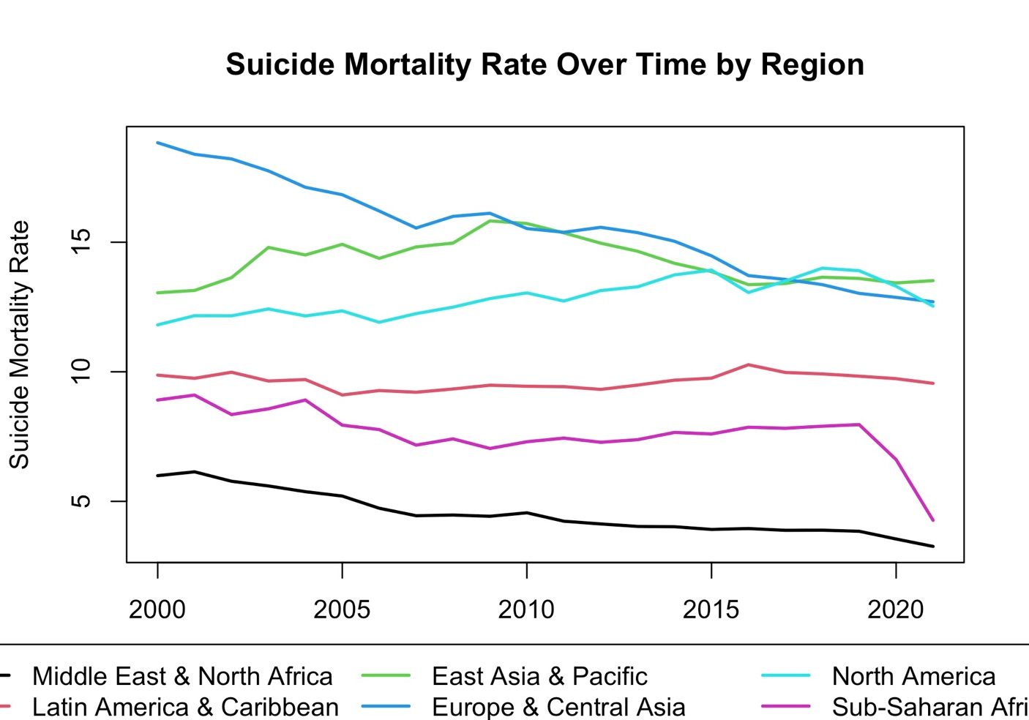
Figure 3
Figure 3 summarizes how suicide mortality rates have changed across major world regions included in the sample. Regions such as Europe & Central Asia and East Asia & Pacific consistently exhibit the highest suicide rates, though Europe & Central Asia show a slow decline over time. Regions such as North America and Latin America & the Caribbean maintain mid-range levels, with North America showing a slight upward trend. Sub-Saharan Africa and the Middle East & North Africa appear at the lower end of the distribution. This regional breakdown highlights how very different suicide rates are depending on the area of the world you are in.

Methods
This study estimates a linear regression model using panel data, where each observation represents a specific country in a specific year. The dependent variable, SuicideRate_{it}, measures the suicide mortality rate for country i in year t. The independent variables include government capital expenditure (CapitalExp_{it}), current expenditure (CurrentExp_{it}), life expectancy (LifeExpectancy_{it}), out-of-pocket healthcare expenditure (OOPexp_{it}), and public education spending (PublicEduSpend_{it}), all indexed by country and year. The error term, $ϵ_{it}$, represents the unobserved factors that affect suicide mortality that are not captured by the included variables. By including both i and t in the notation, it highlights the panel structure of the data, indicating that the model accounts for variation across countries and over time.
The linear regression model is as follows:
$${SuicideRate}_{it}=β_{0}+β_{1}{CapitalExp}_{it}+β_{2}{CurrentExp}_{it}+β_{3}{LifeExpectancy}_{it}+β_{4}{OOPexp}_{it}+β_{5}{PublicEduSpend}_{it}+ϵ_{it}$$

Since the dataset is compiled from multiple international sources, not every country has reported all variables for every year. After merging the datasets and restricting the analysis to observations with complete information on suicide mortality, health expenditures, life expectancy, and education spending, the usable sample decreases from 1,276 country-year observations to 240. This reduction reflects the listwise deletion of missing values to ensure that the regression model is estimated on a consistent set of countries and years, but it also limits the sample size and may affect the generalizability of the results.
It is necessary to consider whether the core assumptions of the Ordinary Least Squares (OLS) framework are likely to hold in this model before beginning to interpret regression results. The first assumption of the OLS framework is linearity, which, when applied to the model, requires that the relationship between each independent variable and suicide mortality is linear. This may provide a reasonable approximation, but the relationship is unlikely to be truly linear in practice. Using CurrentExp as an example, the marginal change from zero to one percent or one to two percent likely has a larger effect on the suicide mortality rate than the change from twenty to twenty-one percent. The next assumption, random sampling, is debatable whether it is satisfied because the data consists of all available country-year observations rather than a random draw from a population; however, by acknowledging this limitation, we can still use the data set to support inferences. The third assumption, zero conditional mean, is unlikely to fully hold because there are many important determinants of suicide mortality rate that are not included in the model and may be correlated with the other variables, creating omitted variable bias. Such determinants could include unemployment rates, cultural stigma, substance abuse, and more. The last assumption, variation in X, requires all the independent variables to exhibit meaningful variation across countries and over time. This assumption is satisfied in the data set as public spending, life expectancy, and out-of-pocket costs differ significantly across countries and time. Taking into consideration all the OLS assumptions, the results from the model cannot be used as causal estimates, but they can still provide insightful analysis.

Results
The table below presents the results from the linear regression model that estimates the relationship between the indicator variables and suicide mortality rates across countries. The model explains about 23.6% of the variation in suicide rates, R² = 0.236, and the overall F-statistic indicates that the set of predictors is jointly significant, F = 14.48. Several of the indicator variables show statistically significant relationships with suicide mortality.
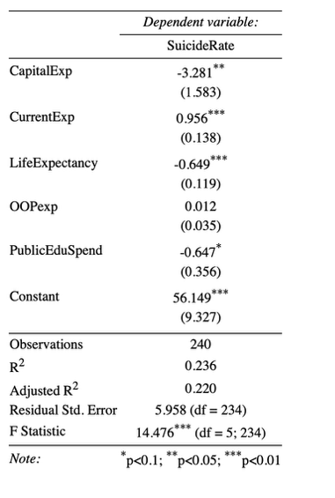
Table 2
CapitalExp, measured as capital health spending as a percentage of GDP, is negatively associated with suicide rates with a coefficient of -3.28 and a p-value of 0.039, significant at the 5% level. This negative coefficient could. suggest that higher government investment in health infrastructure, such as hospitals, equipment, and construction, is correlated with reductions in suicide rates. On the contrary, CurrentExp, which is current health spending as a percentage of GDP, shows a highly significant positive relationship with suicide mortality with a coefficient of 0.96 and a p-value of less than .001. Current health expenditures reflect routine operating costs such as wages, medical supplies, and administrative expenses. This result suggests that countries that invest more in the budget of day-to-day system operations tend to experience higher suicide rates, though it is possible this reflects a strain on healthcare systems or reverse causality rather than implying that current spending itself increases suicide mortality.
LifeExpectancy is a strong and highly significant predictor of suicide mortality with a coefficient of -0.65 and a p-value of less than .001. This relationship indicates that countries with longer average life expectancies tend to have lower suicide mortality rates. This relationship aligns with other public health evidence that populations with higher life expectancies typically benefit from better overall health conditions, stronger healthcare systems, and better access to preventative services. Higher life expectancy may also capture the combined effects of socioeconomic stability, effective chronic disease management, and improved quality of life, all of which can contribute to reducing risk factors associated with suicide. OOPexp represents the Out-of-pocket health expenditure as a percent of total health spending that a population faces. Within the model, OOPexp is not statistically significant and indicates that the share of healthcare costs paid directly from individuals does not show a measurable national-level correlation with suicide mortality in this dataset, with a coefficient of 0.01 and a p-value of 0.73. This lack of significance could suggest that variations in financial burden at the point of care may not translate into systematic differences in suicide rates across countries. The last indicator variable, PubEduSpend, reflects the amount of investment into public education systems as a percent of GDP and has a coefficient of -0.65, but it is only marginally significant at the 10% level with a p-value of 0.071. Although this estimate is less significant than the others, the relationship is consistent with what we would expect, as higher educational attainment is often correlated with better socioeconomic outcomes, stronger social support systems, and better access to information and resources, all of which may reduce the likelihood of suicide.
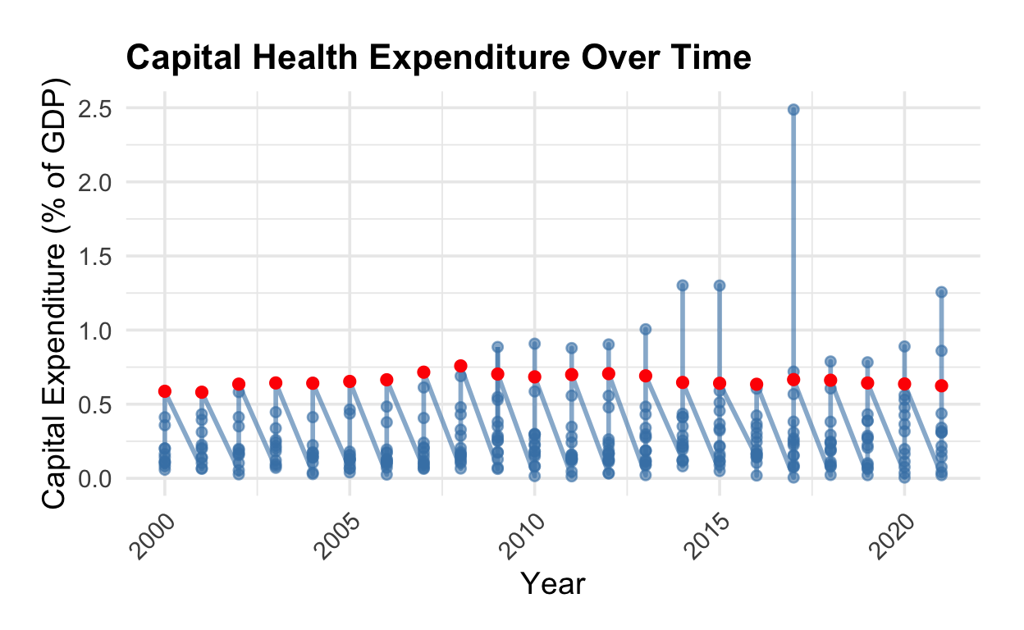
Figure 4
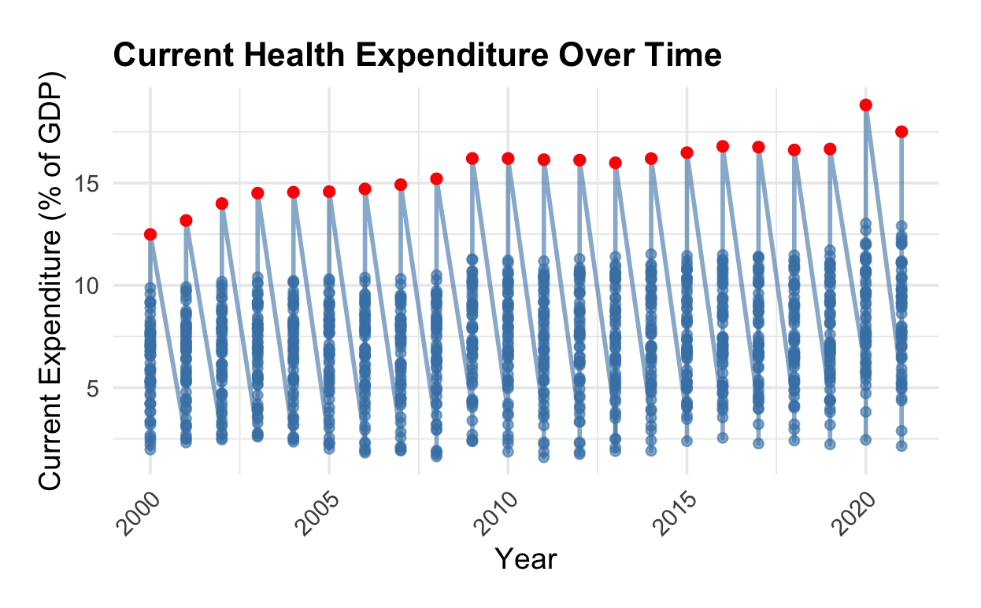
Figure 5
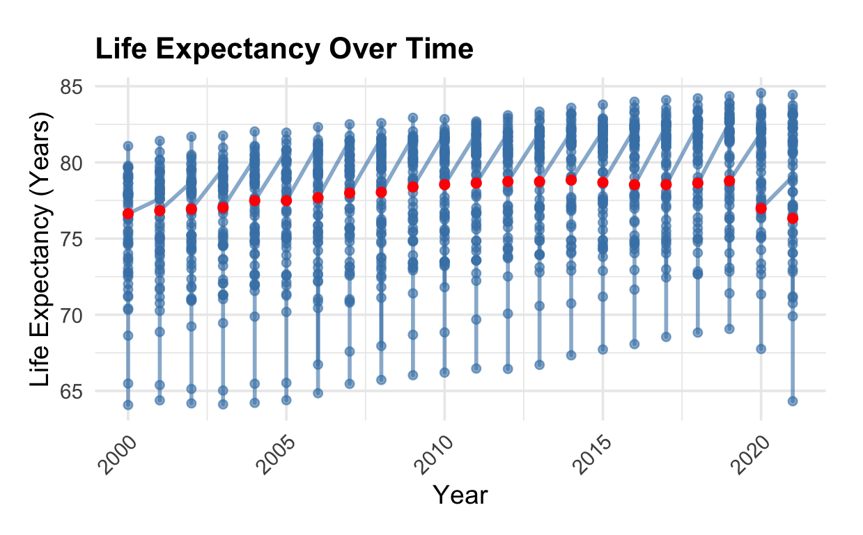
Figure 6
Figures 4 through 6 depict the trends in the statistically significant indicators over time, helping to contextualize the regression results. Across all three measures, the scatter points reveal substantial cross-country variation each year, while the red dots stand out by occupying the upper range of expenditure and the mid-to-lower range of life expectancy relative to peer nations. In current health expenditures, the United States is a very pronounced outlier, spending substantially more than all other high-income countries throughout the entire period. Taken together, the three graphs illustrate that the United States spends more yet achieves comparatively lower life expectancy and as depicted earlier, its suicide mortality rates are increasing while the average suicide mortality rate for its peer countries is declining.
Overall, the results indicate that the different indicator variables related differently to suicide mortality, with capital health investments associated with reductions in suicide rates, while higher current health spending is associated with higher suicide mortality rates, potentially reflecting unmet needs or system strain. These findings highlight meaningful associations; however, the low R² suggests that there are many relevant social, cultural, or economic determinants of suicide that are not observed in the model.

Limitations and Extensions
While the model is able to provide some useful insight into cross-national patterns in suicide mortality, several limitations need to be acknowledged. First, the analysis is constrained by substantial missing data across countries and years. The model uses listwise deletion, causing the sample size to drop from 1,276 observations to merely 240 observations. This reduces statistical power but could also raise concerns about sample selection. Countries with incomplete reporting could be caused by any number of reasons, such as political instability or fragmented systems, and in turn become disproportionately excluded. This could lead to the results reflecting the experiences of more data-rich countries rather than the global population.
Another important limitation is omitted variable bias. There is a wide set of socioeconomic, cultural, and institutional factors that influence suicide mortality that are not included in the model. Such as unemployment rates, income inequality, alcohol and substance use prevalence, mental health service availability, and cultural stigma around both mental health and suicide. The zero conditional mean assumption does not hold, as many of these omitted variables are likely to correlate with the regressors, which in turn is what causes the omitted variable bias. The direction of the bias that occurs is dependent on the correlation structure for the different omitted variables. Larger spending on public education tends to coincide with stronger economies and stronger and/or more widely available social services, both of which we would expect to see lower suicide mortality rates. By omitting these variables, there is likely a downward bias in the estimated effect of education spending, resulting in an underestimate. On the contrary, health spending often increases in response to poor population health or rising mortality and this reverse-causal relationship may bias the estimates upward. This would make the positive association between current health expenditure and suicide mortality an overestimate of any true effect. Overall, these coefficients should be interpreted as descriptive correlations rather than causal effects as some coefficients may overstate or understate the magnitude fo the true relationships.
Additionally, the model assumes linearity in relationships that may not be linear in practice. For instance, the marginal effect of health expenditure is highly unlikely to be constant across the spending distribution as small increases at low levels of spending may have different implications than increases in already well-funded systems. With the small number of observations, it becomes difficult to explore more complex model structures that might help better reflect how these factors influence suicide rates.
In order to strengthen the model for future analysis, the dataset could be expanded using alternative sources to improve completeness in the data and reduce sample selection bias. It would also be beneficial to include additional indicator variables, such as measures of economic conditions or mental health resources, to help mitigate omitted variable bias and improve the plausibility of the zero conditional mean assumption from the OLS framework. Instrumental variables could be used to address the problem of reverse causality, specifically in the relationship between current health expenditure and suicide mortality rates. Last, nonlinear models should be considered to more accurately reflect the diminishing marginal effects.
Collectively, these constraints in the model indicate that the estimates represent correlations rather than causal effects, reflecting general patterns across countries. Even so, this analysis helps to provide a framework for future research that incorporates more complete data and more advanced methods.

Conclusions
This analysis provides a cross-national perspective on factors associated with suicide mortality in high-income countries, highlighting several meaningful patterns in how health and social investments relate to population mental health outcomes. The findings from the analysis suggest that larger capital investment in healthcare and higher life expectancy are associated with lower suicide mortality, while higher current health expenditure is positively correlated with suicide rates, likely due to reporting differences, system strain, or reverse causality. While these relationships should be interpreted as descriptive correlations rather than causal, they help to underscore the importance of long-term health infrastructure, overall population health, and broader social conditions that may influence suicide risk. Even with limitations such as missing data and unmeasured factors, the analysis provides a useful starting point for future research that relies on more complete data and stronger methodological approaches. In the long run, lower suicide mortality rates will likely require coordinated efforts across healthcare systems, social services, and broader well-being initiatives.

References
Han, B., Kott, P. S., Hughes, A., McKeon, R., Blanco, C., & Compton, W. M. (2016).
Estimating the rates of deaths by suicide among adults who attempt suicide in the
United States. Journal of Psychiatric Research, 77, 125–133.
https://doi.org/10.1016/j.jpsychires.2016.03.002
Martínez-Alés, G., Jiang, T., Keyes, K. M., & Gradus, J. L. (2021). The Recent Rise of Suicide
Mortality in the United States. Annual Review of Public Health, 43(1).
https://doi.org/10.1146/annurev-publhealth-051920-123206
Canetto, S. S., & Sakinofsky, I. (1998). The Gender Paradox in Suicide. Suicide and Life
Threatening Behavior, 28(1), 1–23. https://doi.org/10.1111/j.1943
278x.1998.tb00622.x
World Bank. (2024). Suicide mortality rate (per 100,000 population) [Data set]. World
Development Indicators. Retrieved February 6, 2025, from
https://data.worldbank.org/indicator/SH.STA.SUIC.P5
World Bank. (2024). World Development Indicators [Data set]. Retrieved February 6, 2025,
from https://databank.worldbank.org/source/world-development-indicators

‌

‌

‌

